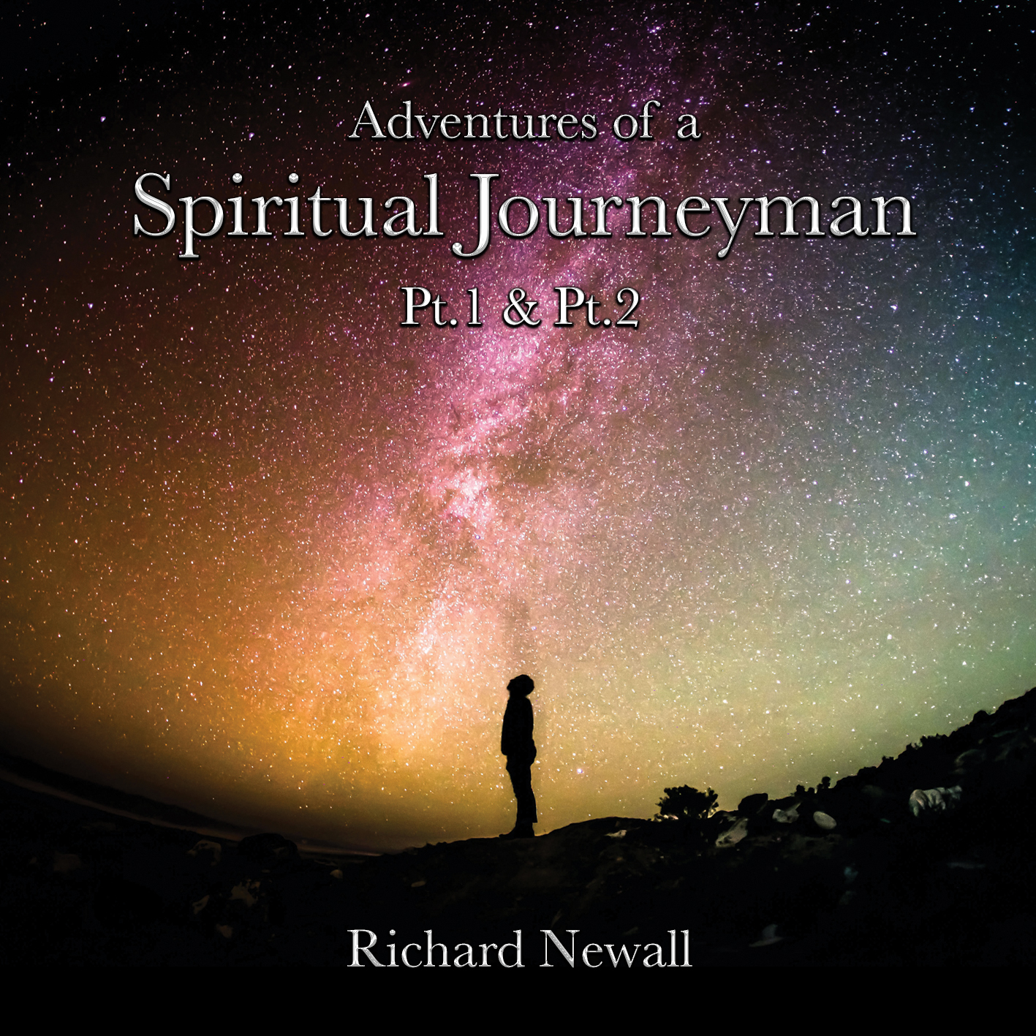

ADVENTURES OF A SPIRITUAL JOURNEYMAN PT1 & PT 2

Spiritual Journeyman
Spiritual journeyman is a term for the many paths of a living education and can be used to describe life's process of continual learning. Although the term Spiritual journeyman is typically traditional, Spiritual journeyman is used to refer to current concepts of adult education: life-long learning, up-skilling, the knowledge wave, and modern apprenticeships.

IS THIS YOU?

- Are you lost in a repetitive cycle of negative behaviour?
- Are you aware that you are not for filling your potential?
- Are you tired of failing at relationships?
- Do you want to know what love really is?
- Have you dreamed of the day you are truly happy with yourself?
- Who am I?
If you can answer YES to any or several of these questions, then “Adventures of a Spiritual Journeyman“, can help you!

THANK YOU FOR COMING THIS FAR ON YOUR JOURNEY
I RECOMMEND THAT YOU READ THIS BEFORE LISTENING

I CANNOT STRESS ENOUGH JUST HOW IMPORTANT IT IS TO FOLLOW THE INITIAL STEPS OF SURRENDER & TRUST

SURRENDER

The key to this process is surrender.
What does surrender mean?

Firstly, and this is the basis for your transformation, without this vital component you will continue in the same old way, and if that happens that’s O.K., and maybe for you it’s not quite the right time.

To surrender is to relinquish your attachment to a preconceived outcome and to enter a private and personal commitment with your God (the creator) through your soul. This is a sacred act and I advise full commitment as the rewards are equal to the input.

NOTE: If you only commit in a partial way you will only get weak or unfulfilling results. There are no threats, it just won’t work as well ……

TRUST

Things can get a little uncomfortable during this time of transformation, and you will find that you have developed a new honesty, one that is total truth, and not a version of the truth, this can wobble some relationships and you may find yourself distancing from one or two of your group or circles of friends. Some past acquaintances may fall by the wayside, but others will be drawn to your beautiful light. Fundamentally, you will develop a truly sincere and honest relationship with yourself which will grow awareness of the authentic version of you. You will be able to love yourself for who you really are and not be the diluted version of someone else’s ideals.

WHAT DOES THIS TRANSFORMATION FEEL LIKE?
Well! I, at first asked questions, a kind of exchange of thoughts with my God.
(I use the term “my God” as I have always had a personal and intimate relationship with God, and this doesn’t conform to any religious template).
The answers that came were not of my instigation - not of my historical thoughts or knowledge, in other words not preconceived.
At first, I was a little shocked, I looked at the responses and some were quite uncomfortable to hear, I was amazed that my old tried and tested reactions weren’t always right and in fact, I had to re-think quite a few of my automatic responses.
(Heaven forbid, had I been wrong all this time?!)
As mentioned previously, this process is transformative, and can be a little uncomfortable at times, but if you commit to the unfoldment through your Soul, you will re-discover your true self and will be amazed by your transformation and zest for life, whilst embracing the full potential of who you are. Spiritual apprenticeship is ongoing and never ending, your evolution is unique to you, enjoy the journey!
Recommended listening practice

It is good practice to find yourself a comfortable chair in a quiet space where you won’t be disturbed for about an hour.
Set your player volume at a comfortable level (not too quiet).
Press play and close your eyes.
Track one is my back story which I would like to share with you, however it is not imperative to play it every time you listen to the Spiritual Journeyman. With subsequent listening’s you may wish to start on track two.

A BRIEF HISTORY OF THE CREATION OF THE SPIRITUAL JOURNEYMAN RECORDING
I started this recording back in 2013 when I first got myself a new computer and invested in a state-of-the-art recording software system. This was my first experiment into recording for myself and with a little help from “Garageband”. I made a short track which blew my mind, it was really quite good. Not being one to blow my own trumpet I did nothing with it and just played it to a couple of friends now and then, who all said that I should do something with it; I knew it had to be for something special, but I had no idea what it was.

The years went by and with the help of Lewis Brown, my first sound engineer, we made CDs for many of the top mediums and spiritual teachers in the U.K. putting their spoken words to music and hopefully creating the space for the teacher to share their truths. I have made over 50 such recordings over the years, along with a few of my own.

However, during the past decade I had become unsettled and unfulfilled with my spiritual progress. I was stuck in a ‘Groundhog Day’ loop of “nearly but not quite” getting it …. I was not connecting. I didn’t feel close to neither my spirit, nor my God. I was lost and then along came Covid19, and a forced break was hoisted upon us all. My usual three or four weeks away each year at a spiritual centre were cancelled and I was devoid of learning and teaching from outside.

That’s when I started to sit in meditation on my own and I truly learned to surrender and to give control of my education to God. The transformation was instant, ongoing, and profound and I have tried to capture this, and a method, in the recording of ‘Adventures of a Spiritual Journeyman Pt1 & Pt2’ so that you too can share this experience and have your own incredible adventure.

ADVENTURES OF A SPIRITUAL JOURNEYMAN PT1 & PT 2

TRACK 1 INTRODUCTION
04:08 My story

TRACK 2 ADVENTURES OF A SPIRITUAL JOURNEYMAN Pt 1 & Pt 2
28:50 The Journey begins

TRACK 3 EVOLUTION
11:22 A Time for your Journey

TRACK 4 REMINDERS
06:36 A beautiful rhythmic track, with ‘reminders’ spoken in Cherokee

LYRICS TO “REMINDERS”

GOD You are the creator.
CHEROKEE Trust me.
GOD Surrender and trust.
CHEROKEE God.
GOD You are made in my image.
CHEROKEE Trust me.
CHEROKEE Your job is to know me.
GOD Listen to your heart and trust your Soul.
CHEROKEE Love.
GOD The truth is, I never leave you.
CHEROKEE Love me.
CHEROKEE Trust
GOD Love

CREDITS

KEYBOARDS - RICHARD NEWALL & ELLIOTT THORNHILL
FLUTE - RICHARD NEWALL & ELLIOTT THORNHILL
PERCUSSION - ELLIOTT THORNHILL
THE VOICE OF GOD - TERRY BURNS
THE NARRATOR - RICHARD NEWALL
THE JOURNEYMAN - RICHARD NEWALL
CHEROKEE VOICE - RICHARD NEWALL
SOUND ENGINEER 2013-19 - LEWIS BROWN
SOUND ENGINEER 2019- Present - ELLIOTT THORNHILL
PHOTO COVER - GREG RAKOZY
PHOTO BACK & INSIDES - ANDY HOLMES
SPOKEN QUOTE (WATER) - ALAN WATTS

MUSIC BY RICHARD NEWALL & ELLIOTT THORNHILL
WRITTEN AND PRODUCED BY RICHARD NEWALL
RECORDED, PRODUCED AND MASTERED AT ONE VOICE STUDIO
BENFLEET, ENGLAND SS7 1HX

W: WWW.ONEVOICEMUSIC-CD.COM
W. WWW.ONEVOICEMUSIC-DOWNLOADS.COM
E: ONEVOICEMUSIC@BTINTERNET.COM

COPYRIGHT: ONEVOICEMUSIC 2022
HIRING, LENDING, PUBLIC PERFORMANCE, AND BROADCASTING OF THIS RECORDING IS PROHIBITED.

MADE IN ENGLAND

ACKNOWLEDGEMENTS AND THANKS

GOD: FIRST LAST AND EVERYTHING.

TERRY BURNS: VOICEOVER ARTIST, ACTOR, AND FRIEND. HIS BELIEF AND COMMITMENT TO THIS PROJECT HAS BEEN ABOVE AND BEYOND.

ELLIOTT THORNHILL: SOUND ENGINEER, MUSICIAN, TECKIE GENIUS, AND FRIEND.

LAURA THORNTON: GRAPHIC DESIGN - PURE GENIUS & BEAUTY.

DARREN BRITTAIN: PROOF READING, WEB DESIGN AND GURU, FRIEND.

NEALE DONALD WALSCH: AUTHOR, INSPIRER & TEACHER.

DAVID VEALE & SUE BROWN: FELLOW JOURNEYMEN

GOD: FIRST LAST AND EVERYTHING.

*THIS RECORDING IS INTENDED TO BE AN EXPERIENCE TO HELP YOU HEAL THE PAST MISCONCEPTIONS THAT HAVE SHAPED THE WAY YOU HAVE PERCEIVED YOURSELF AND GOD*

READING THAT REALLY HELPED ME ON MY JOURNEY

JONATHAN LIVINGSTON SEAGULL RICHARD BACH
CONVERSATIONS WITH GOD NEALE DONALD WALSCH

